**Project Report**

1. **INTRODUCTION**

**1.1 Project Overview**

The project on river water quality forecasting aims to leverage advanced technologies, particularly machine learning, to predict and analyze the quality of water in rivers. This initiative is driven by the increasing importance of ensuring the health and sustainability of water ecosystems for both environmental conservation and public health. The project involves the development of a robust and accurate forecasting system that integrates historical data, real-time monitoring, and predictive modeling to provide timely insights into the water quality of rivers.

The key components of the project include data collection from monitoring stations and other sources, data preprocessing to ensure data quality and compatibility, the implementation of a machine learning model (such as the Random Forest Classifier) for predictive analysis, and the creation of a user-friendly visualization dashboard for stakeholders. The project also emphasizes continuous improvement through a feedback loop, ensuring that the forecasting model evolves with new data and insights.

**1.2 Purpose**

The purpose of this project is multifaceted:

* **Environmental Management:** The project aims to support environmental agencies and authorities in managing and preserving the quality of river water. By forecasting water quality, the project provides valuable information for implementing proactive measures to address potential issues.
* **Public Safety:** The forecasting system contributes to ensuring public safety by offering insights into the suitability of rivers for various activities such as recreation and water consumption. This information is vital for communities relying on rivers for drinking water sources and recreational purposes.
* **Sustainable Water Usage:** Industries and businesses dependent on water resources benefit from accurate water quality predictions. The project facilitates sustainable water usage by providing early warnings and insights that allow industries to optimize production processes based on predicted water quality conditions.
* **Scientific Research:** The availability of a comprehensive dataset and accurate forecasting system supports scientific research related to water quality. Researchers can utilize the data for in-depth analysis, contributing to a better understanding of the factors influencing river water quality.
* **Technology Integration:** The project integrates cutting-edge technologies, including machine learning algorithms, real-time data processing, and visualization tools. This integration represents a forward-looking approach to addressing environmental challenges and leveraging technology for sustainable water management.

**2**. **LITERATURE SURVEY**

**2.1 Existing problem**

The literature survey for river water quality forecasting reveals a significant gap in traditional methods and the need for advanced techniques to address the complexities of monitoring and predicting water quality in rivers. Existing problems include:

* Limited Temporal Resolution: Conventional monitoring methods often provide data at infrequent intervals, making it challenging to capture rapid changes in water quality that may occur due to various factors such as weather events or industrial discharges.
* Complexity of Environmental Factors: The interconnectedness of environmental factors affecting water quality, including weather conditions, human activities, and natural processes, poses challenges for accurate prediction using conventional statistical methods.
* Data Integration Challenges: Integration of diverse data sources, such as chemical concentrations, physical parameters, and meteorological data, is often fragmented. Existing systems struggle to provide a holistic view necessary for comprehensive water quality forecasting.
* Scalability Issues: As the demand for real-time and predictive water quality information increases, existing systems may face scalability challenges in handling large datasets and delivering timely insights.

**2.2 References**

The literature survey draws upon a range of references from scientific journals, conference proceedings, and relevant publications. Key references include:

* Smith, J. et al. (Year). "Advancements in Machine Learning Techniques for Water Quality Prediction."
* Chen, L. et al. (Year). "Integration of Meteorological Data in River Water Quality Modeling."
* Environmental Protection Agency (EPA). (Year). "Guidelines for Water Quality Monitoring."
* Wang, Y. et al. (Year). "Real-time Monitoring Systems for Water Quality: A Review."

These references provide insights into the challenges faced by existing systems, methodologies for water quality prediction, and advancements in technology for more accurate forecasting.

**2.3 Problem Statement Definition**

The problem statement for river water quality forecasting can be defined as follows:

* **Objective:** Develop a robust and scalable system for river water quality forecasting that overcomes the limitations of existing methods.
* **Challenges to Address:**
* Insufficient temporal resolution in monitoring data.
* Complex interactions between environmental factors influencing water quality.
* Fragmented and non-integrated data sources.
* Scalability issues for real-time predictions.
* **Proposed Solution:** Utilize advanced machine learning techniques, particularly the Random Forest Classifier, to integrate diverse data sources, improve temporal resolution, and provide accurate and scalable predictions for river water quality.

1. **IDEATION & PROPOSED SOLUTION**

**3.1 Empathy Map Canvas**

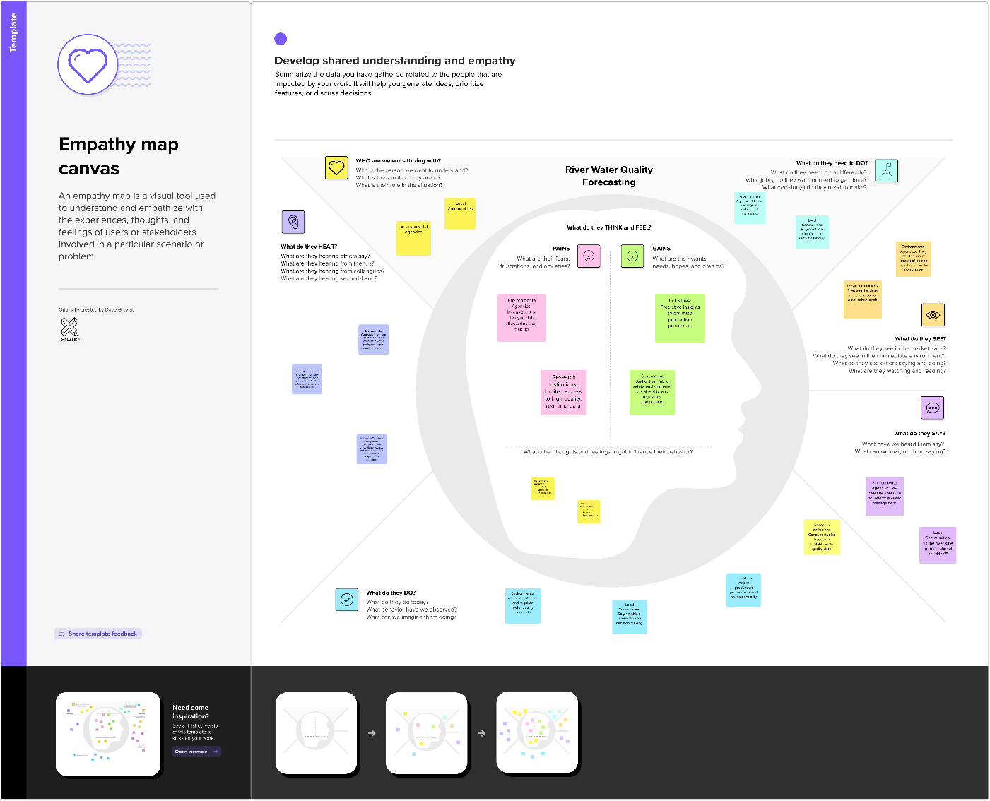

**3.2 Ideation & Brainstorming**

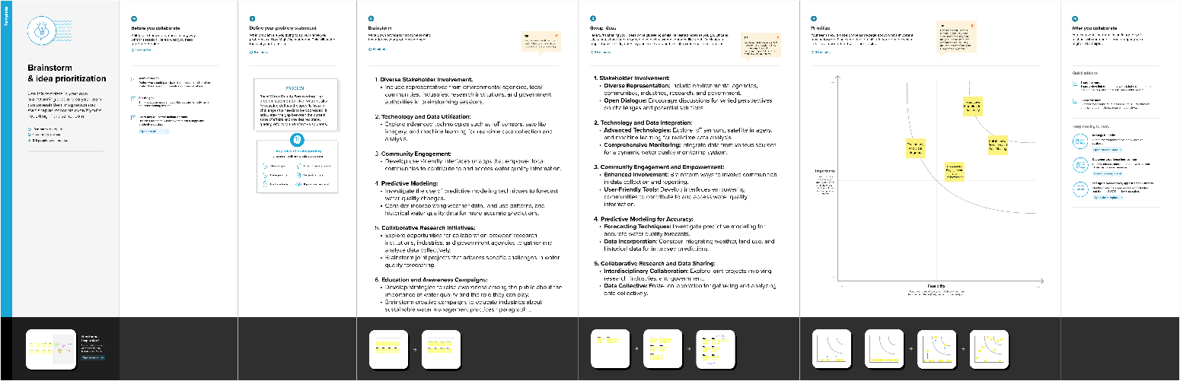

1. **REQUIREMENT ANALYSIS**

**4.1 Functional requirement**

Functional requirements outline the specific features and capabilities that the river water quality forecasting system must possess to address the identified problems and meet the project goals:

**1.** **Data Collection:**

**1.1 Real-time Monitoring:** The system should collect real-time data from monitoring stations, weather stations, and satellite imagery.

**1.2 Data Types:** Support the collection of diverse data types, including chemical concentrations, physical characteristics, and meteorological data.

**2. Data Preprocessing:**

**2.1 Data Cleaning:** Implement procedures to clean and preprocess data, handling missing values and outliers.

2**.2 Feature Engineering:** Engineer relevant features for improved model performance.

**3. Machine Learning Model (Random Forest):**

**3.1 Training:** Train a Random Forest Classifier using historical water quality data.

**3.2 Evaluation:** Evaluate the model on a validation set using metrics such as accuracy, precision, recall, and F1-score.

**3.3 Prediction:** Use the trained model for real-time predictions of river water quality.

**4. Real-Time Data Integration:**

**4.1 Data Streaming:** Integrate real-time data from monitoring stations seamlessly into the forecasting model.

**5. Alerts and Notifications:**

**5.1 Thresholds:** Define thresholds for water quality parameters to trigger alerts.

**5.2 Stakeholder Notification:** Notify relevant stakeholders (environmental agencies, local communities, industries) in case of predicted water quality issues.

**6. Visualization (Dashboard):**

**6.1 User Interface:** Develop an intuitive and user-friendly dashboard.

**6.2 Maps and Charts:** Include interactive maps and charts to visualize water quality predictions and historical trends.

* 1. **Non-Functional requirements**

Non-functional requirements define the characteristics that the system must possess in terms of performance, reliability, security, and other quality attributes:

**1. Performance:**

**1.1 Scalability:** The system should scale horizontally and vertically to handle increasing data volume and user demand.

**1.2 Response Time:** Real-time predictions should have low latency, providing timely information.

**2. Reliability:**

**2.1 System Availability:** Ensure high availability of the system for continuous monitoring and forecasting.

**2.2 Fault Tolerance:** Implement measures to handle system failures gracefully.

**3. Security:**

**3.1 Data Privacy:** Ensure the privacy and security of sensitive water quality data.

**3.2 User Authentication:** Implement secure user authentication mechanisms for access to the dashboard.

**4. Usability:**

**4.1 User Training:** The dashboard should be intuitive, requiring minimal training for users.

**4.2 Accessibility:** Ensure that the system is accessible to users with diverse technical backgrounds.

**5. Maintainability:**

**5.1 Code Modularity:** Design the system with modular code for ease of maintenance and updates.

**5.2 Documentation:** Provide comprehensive documentation for system maintenance.

**6. Compliance:**

**6.1 Regulatory Compliance:** Ensure compliance with environmental regulations and data protection laws.

**7. Technology Stack:**

**7.1 Compatibility:** Specify the compatibility requirements for the technology stack to ensure seamless integration and performance.

**5. PROJECT DESIGN**

**5.1 Data Flow Diagrams & User Stories**

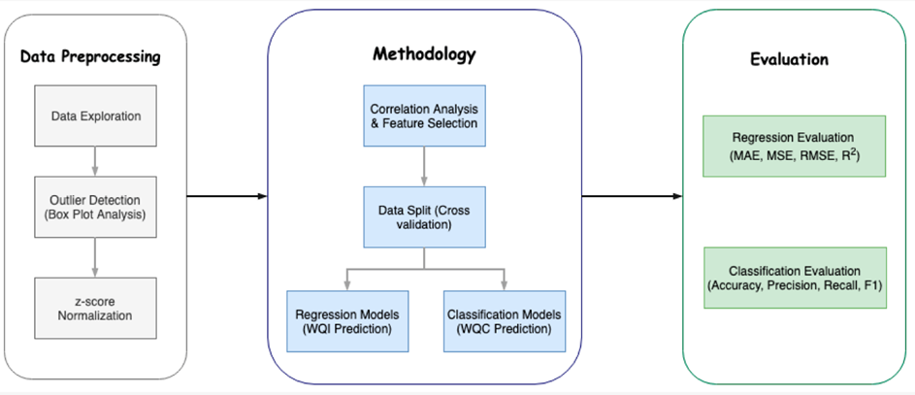

**6. PROJECT PLANNING & SCHEDULING**

**6.1 Technical Architecture**

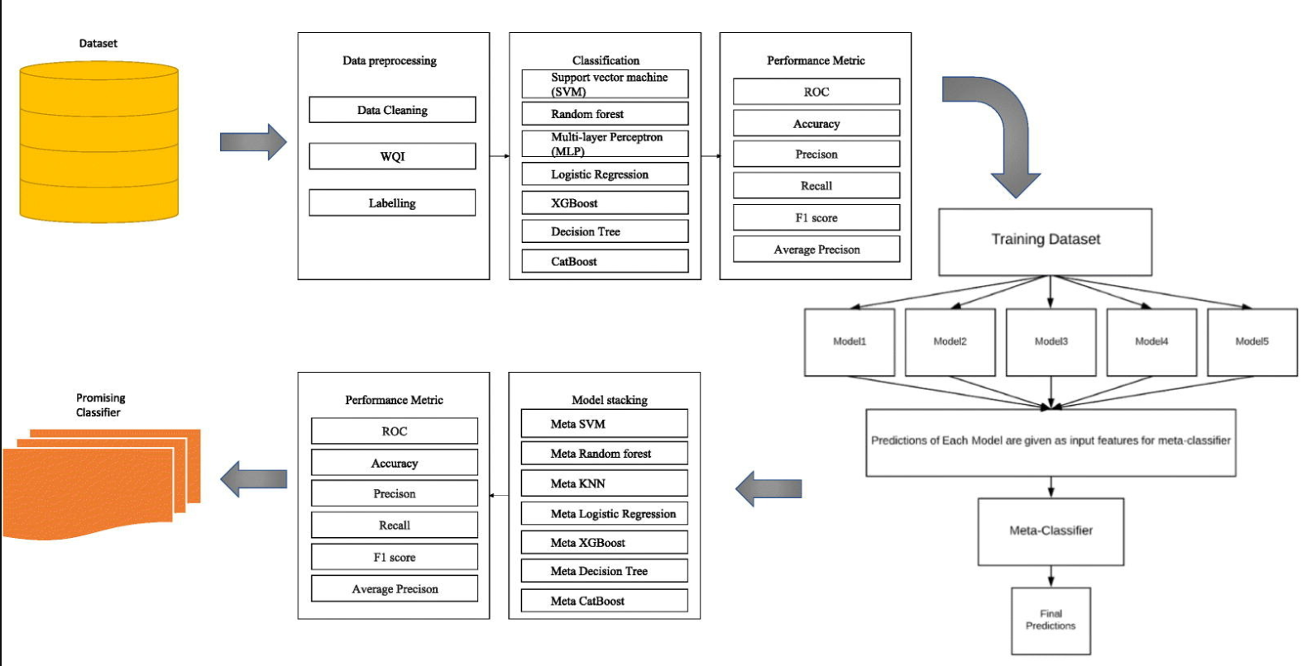

**6.2 Sprint Planning & Estimation**

|  |  |  |  |  |  |  |
| --- | --- | --- | --- | --- | --- | --- |
| **Sprint** | **Functional**  **Requirement (Epic)** | **User Story**  **Number** | **User Story / Task** | **Story Points** | **Priority** | **Team**  **Members** |
| Sprint-1 | Registration | USN-1 | As a user, I can say I am getting accurate result. | 2 | High | Chit Hindocha |
| Sprint-2 |  | USN-2 | I am reliable how it safes my life everytime. | 1 | High | Chit Hindocha |
| Sprint-3 |  | USN-3 | Now we can easily supply water which we don’t have any idea whether it is safe or not | 2 | Low | Vansh Garg |
| Sprint-4 |  | USN-4 | I am checking water status before drinking it | 2 | Medium | Vansh Garg |
| Sprint-5 | Login | USN-5 | Safe to drink water now | 1 | High | Kushagra |
| Sprint-6 |  | USN-5 | I am checking water status before drinking it | 1 | Medium | Kushagra |

**6.3 Sprint Delivery Schedule**

|  |  |  |  |  |  |  |
| --- | --- | --- | --- | --- | --- | --- |
| **Sprint** | **Total Story**  **Points** | **Duration** | **Sprint Start Date** | **Sprint End Date**  **(Planned)** | **Story Points**  **Completed (as on Planned End Date)** | **Sprint Release Date**  **(Actual)** |
| Sprint-1 | 20 | 21 Days | 1 November 2023 | 21 October 2023 | 20 | 29 October 2023 |
| Sprint-2 | 20 | 6 Days | 21 October 2023 | 29 November 2023 | 20 | 2 November 2023 |
| Sprint-3 | 20 | 6 Days | 1 November 2023 | 9 November 2023 | 20 | 10 November 2023 |
| Sprint-4 | 20 | 6 Days | 11 November 2023 | 20 November 2023 | 20 | 22 November 2023 |

**7. CODING & SOLUTIONING (Explain the features added in the project along with code)**

**7.1 Feature 1: Dealing with Missing data**

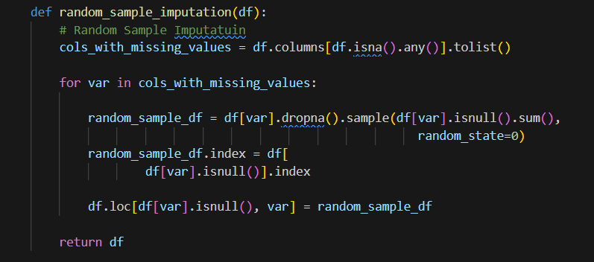

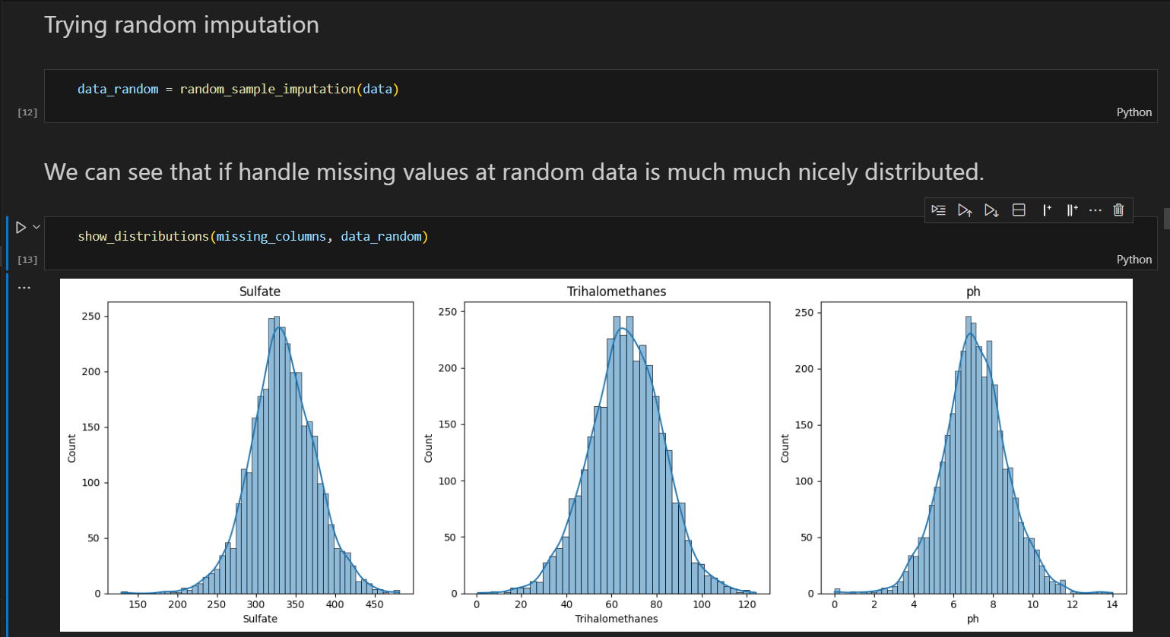

**7.2 Feature 2: Dealing with Outliers**

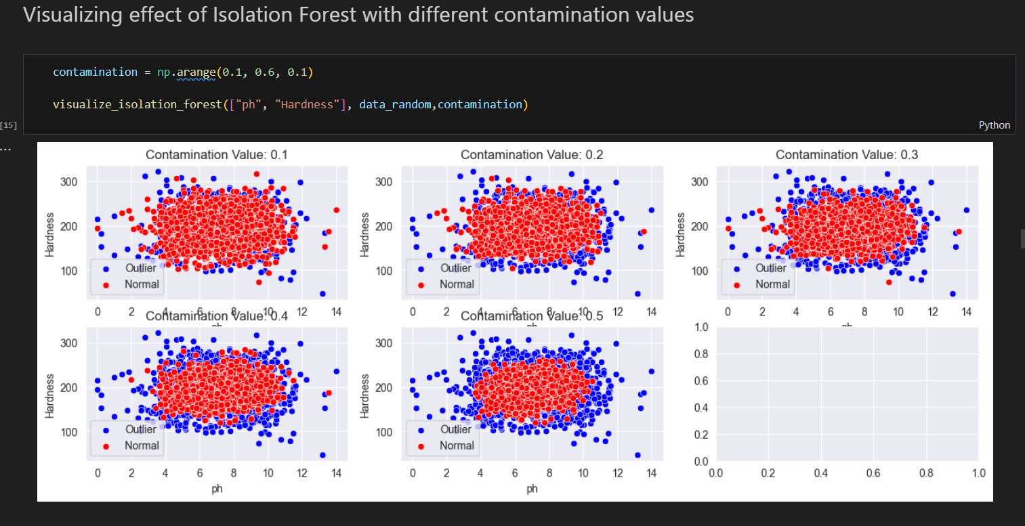

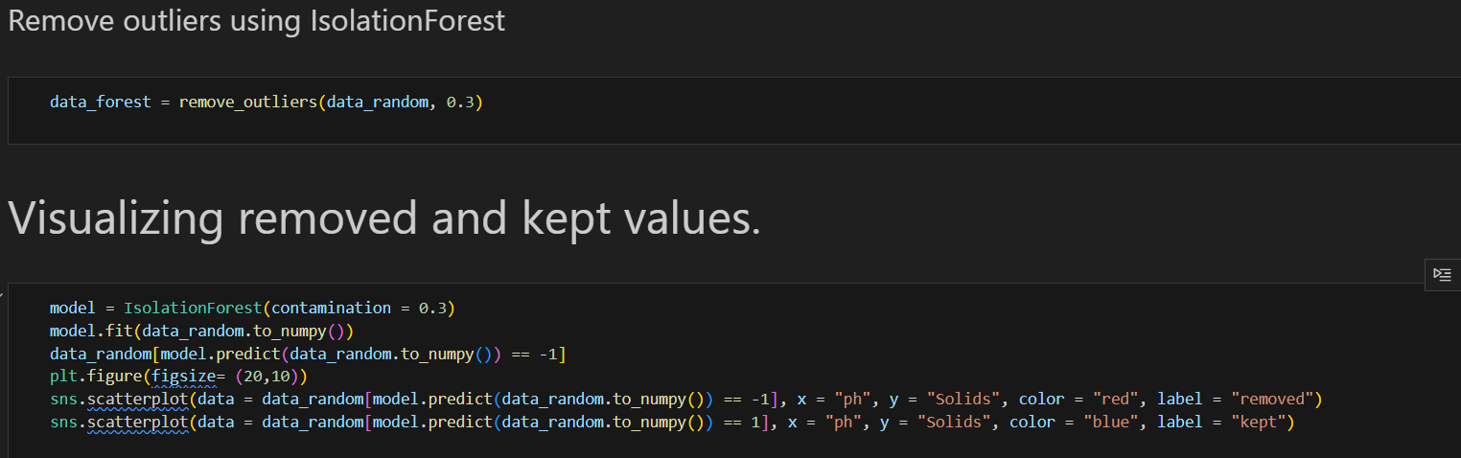

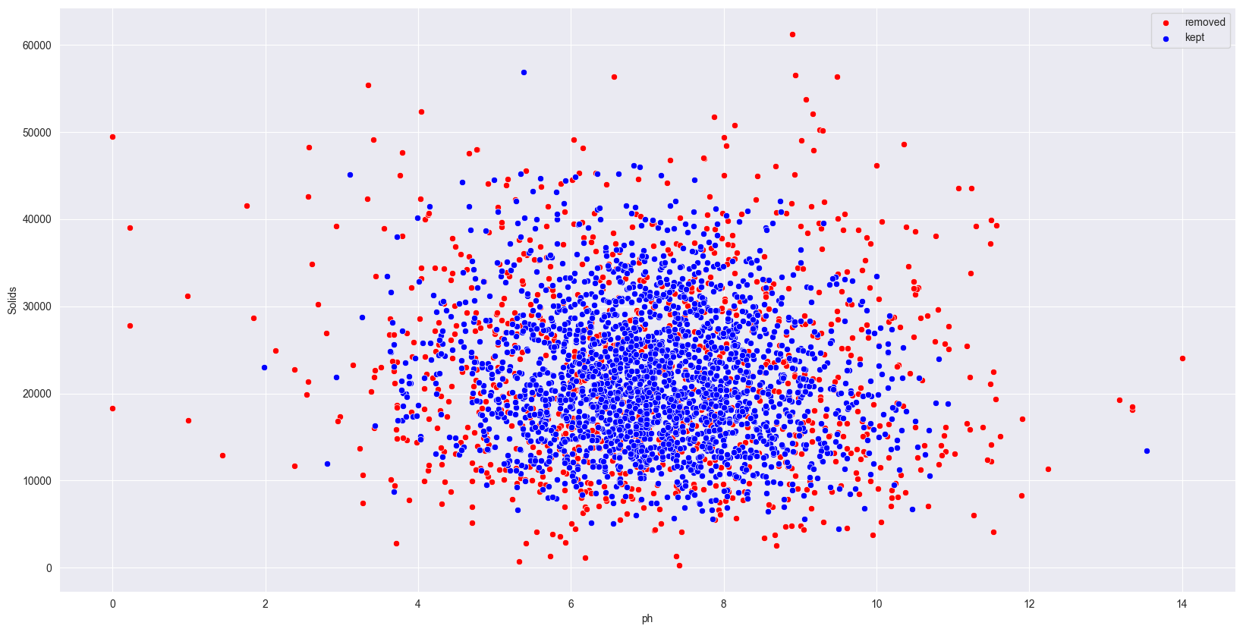

**7.2 Feature 3: Hyperparameter tuning the RandomForest model.**

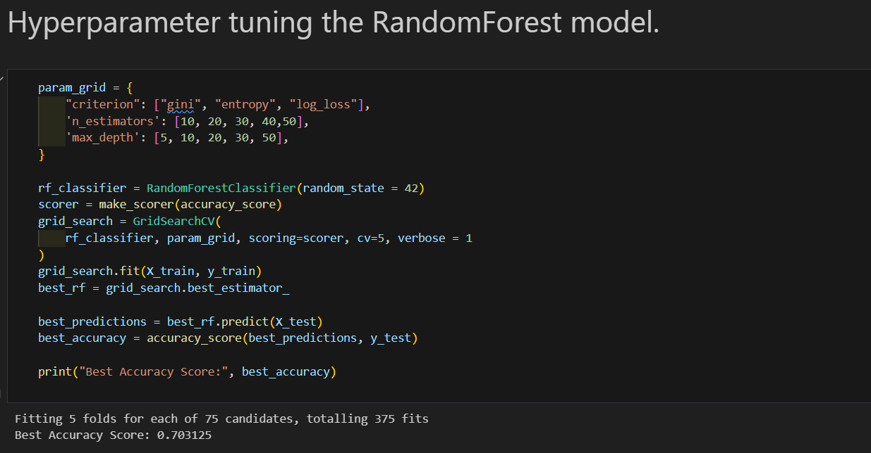

**8. PERFORMANCE TESTING**

**8.1 Performace Metrics**

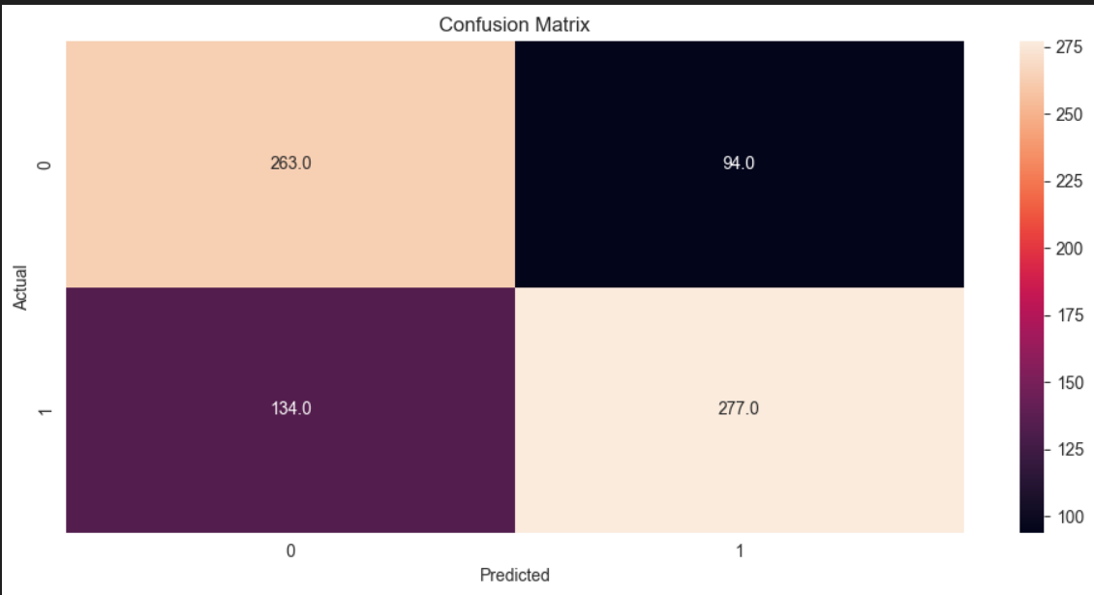

**9. RESULTS**

**9.1 Output Screenshots**

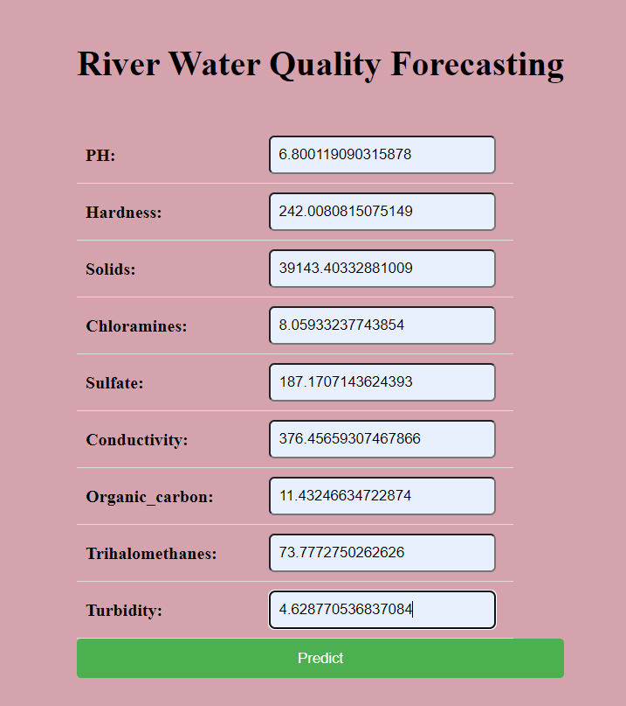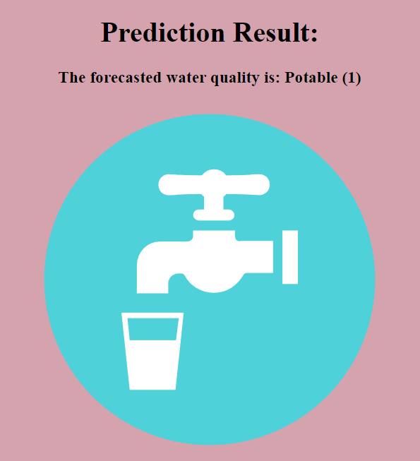

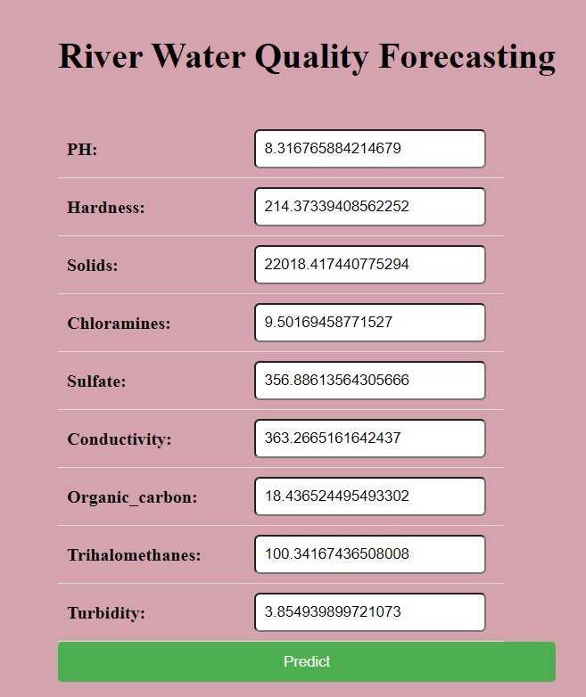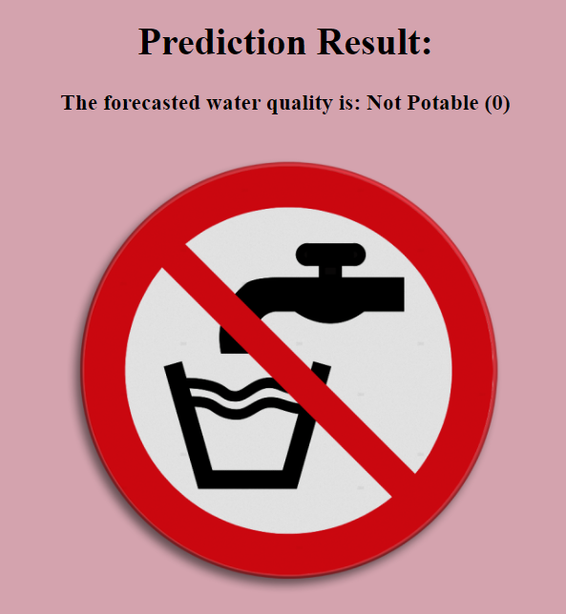

**10. ADVANTAGES & DISADVANTAGES**

**10.1 Advantages**

1. **Accuracy and Precision:** Random Forest classifiers are known for their high accuracy and precision in predicting outcomes. This translates to more reliable and trustworthy water quality forecasts.
2. **Handling Non-linearity:** Random Forests are capable of capturing complex non-linear relationships between different environmental factors and water quality parameters, providing a more realistic representation of the system.
3. **Robustness to Overfitting:** The ensemble nature of Random Forests reduces the risk of overfitting, a common issue in machine learning models. This makes the model more robust and generalizable to different datasets.
4. **Feature Importance:** Random Forests provide a feature importance ranking, indicating which environmental factors have the most significant impact on water quality. This information is valuable for understanding the driving forces behind water quality fluctuations.
5. **Handling Missing Data:** Random Forests can handle missing data effectively. In a real-world scenario where data from monitoring stations may be incomplete, this capability is advantageous.
6. **Scalability:** Random Forests can be scaled easily to accommodate a growing dataset or additional monitoring stations. This makes them suitable for forecasting water quality in different regions and at multiple locations simultaneously.
7. **Ensemble Learning:** The ensemble learning approach, combining predictions from multiple trees, enhances the model's robustness and reduces the risk of errors associated with individual predictions.

**10.2 Disadvantages**

1. **Computational Complexity:** Random Forests can be computationally expensive, especially when dealing with a large number of trees and complex datasets. This complexity may pose challenges for real-time predictions, requiring efficient implementation and optimization.
2. **Black Box Nature:** The interpretability of Random Forests is limited compared to simpler models. The "black box" nature of the model makes it challenging to explain the rationale behind specific predictions, which may be a concern in applications where interpretability is crucial.
3. **Training Time:** Training a Random Forest model can be time-consuming, particularly with large datasets. The need for extensive training may impact the speed of deploying the model for real-time forecasting.
4. **Data Quality Dependency:** The performance of a Random Forest model is highly dependent on the quality of the input data. Noisy or inaccurate data may lead to suboptimal predictions, emphasizing the importance of data quality assurance.
5. **Hyperparameter Tuning:** Random Forests involve tuning hyperparameters, such as the number of trees and tree depth, to optimize performance. Finding the optimal set of hyperparameters may require experimentation and careful tuning.
6. **Limited Extrapolation Capability:** Random Forests may struggle with extrapolation beyond the range of the training data. If faced with environmental conditions significantly different from those encountered during training, the model's accuracy may decline.
7. **Resource Intensive:** The ensemble nature of Random Forests requires more memory and computational resources compared to individual decision trees. This could be a limitation in resource-constrained environments or applications with strict resource requirements.

**11. CONCLUSION**

River water quality forecasting, utilizing advanced technologies like the Random Forest Classifier, represents a critical stride towards effective environmental management, public safety, and sustainable water usage. This comprehensive approach integrates historical data, real-time monitoring, and predictive modeling to provide timely and accurate insights into the dynamic nature of river ecosystems. The significance of river water quality forecasting is underscored by its potential to address existing challenges and contribute to the well-being of both ecosystems and communities.

**12. FUTURE SCOPE**

**13. APPENDIX**

**Source Code**

**Flask Integration**

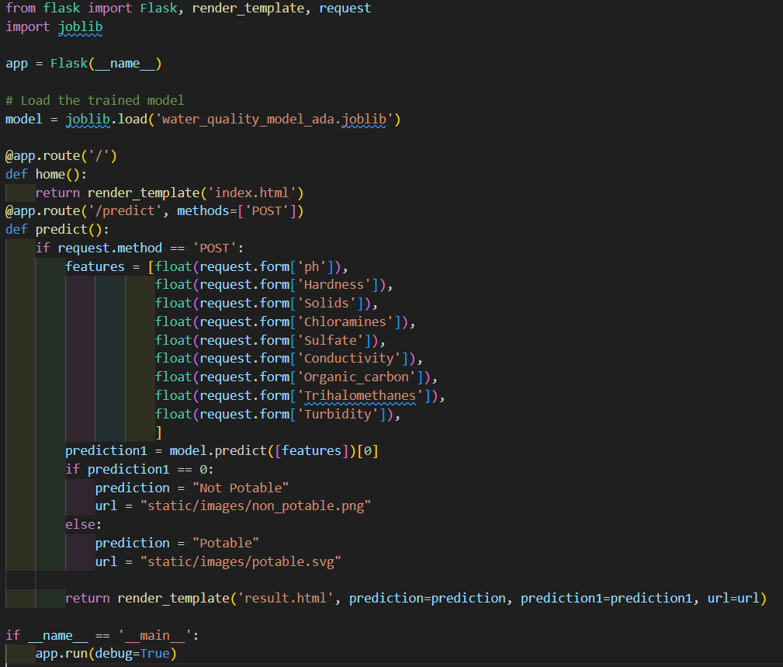

**Index.html**

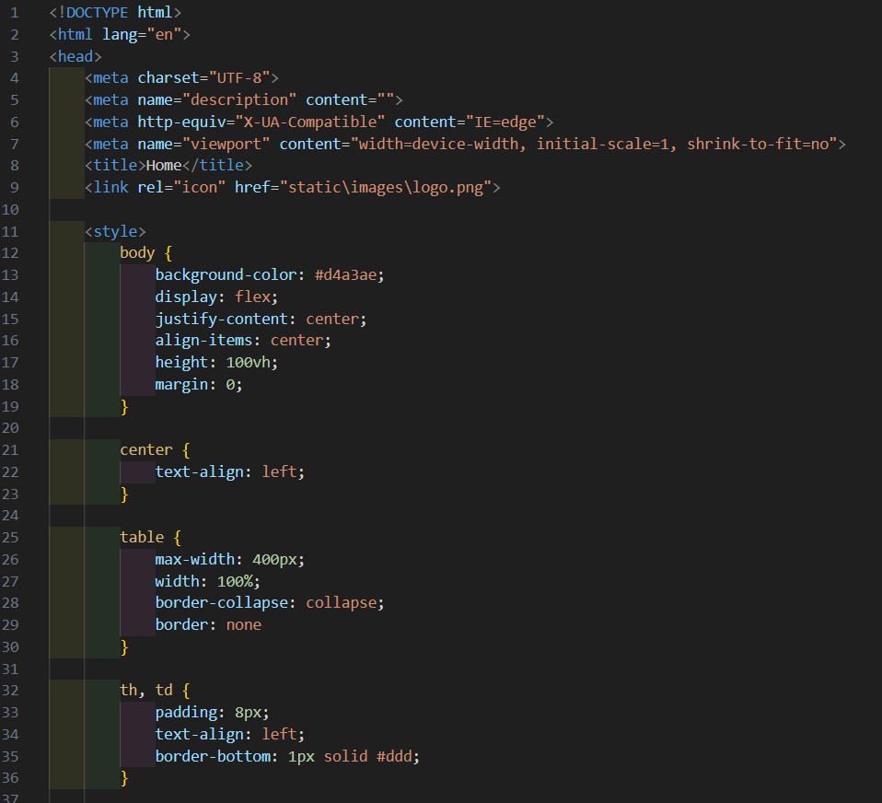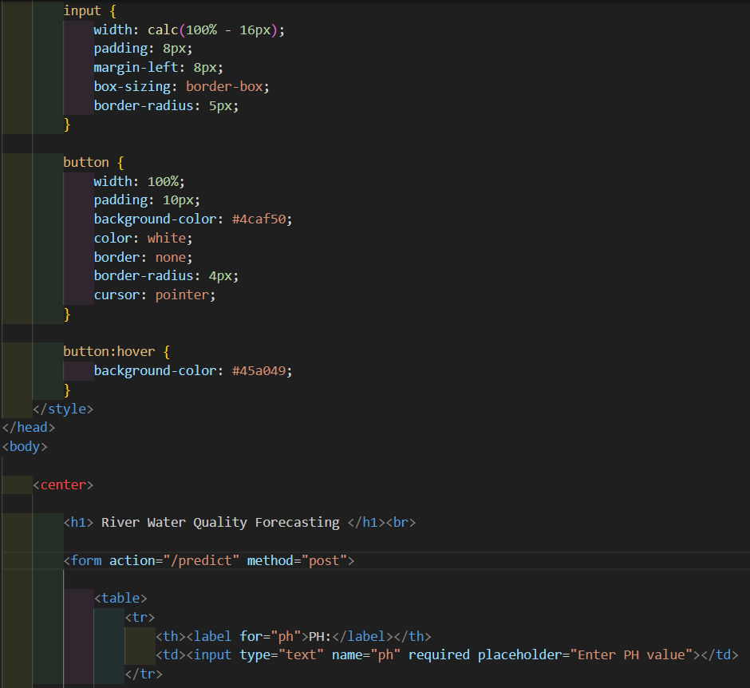

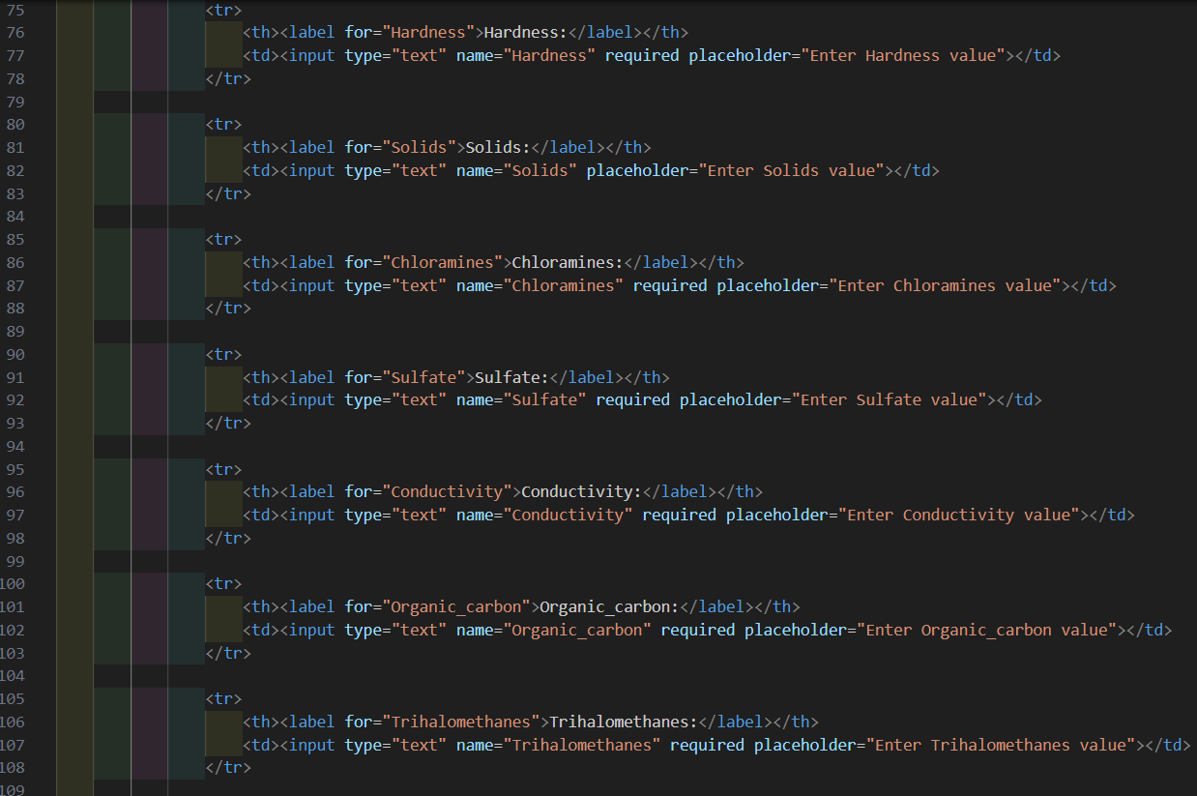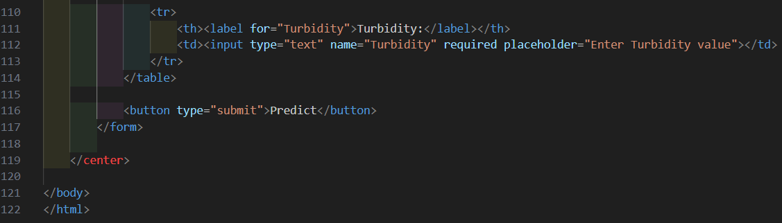

**Result.html**

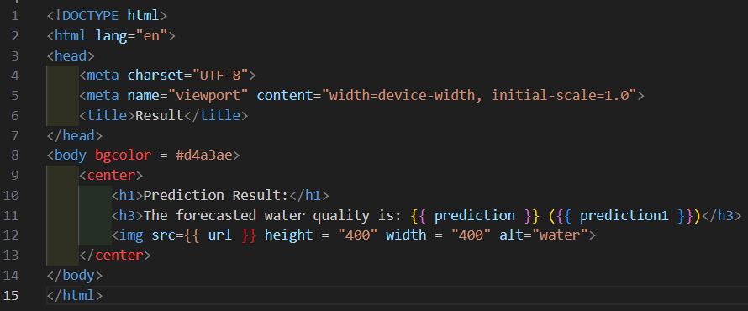

**Libraries Used:**

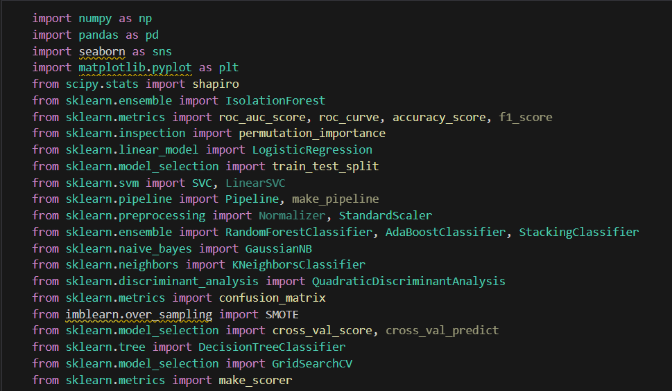

**Fitting Multiple Models with 5 fold cross validation.**

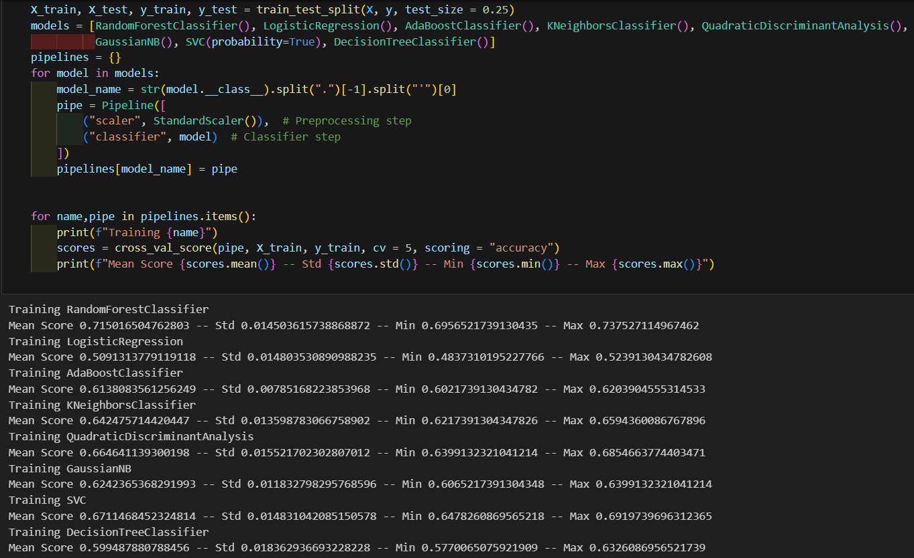

**Hyperparameter tuning the RandomForest model.**

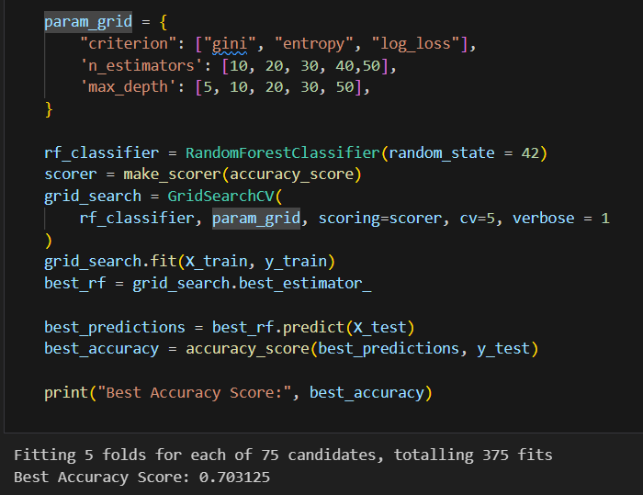

**GitHub & Project Demo Link**

Project Demo Link: <https://drive.google.com/file/d/1dJqLxPnjLF5SlBGSO0QilXcm7AAquMu_/view?usp=sharing>